

Home Learning – Maple Class – Year 3

Date: Friday 18th January 2019 Spring Term Week: 2
______________________________________________________________________________________________

Maths: This week we have been subtracting 3 digit numbers from 3 digit numbers using the number line method. It’s really important that children are confident in using a range of methods so please encourage them to practise this way.
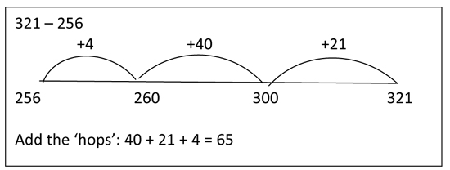

Try these sums using the “frog method”
a) 349 – 176 =
b) 522 – 333 =
c) 435 – 286 =
d) 647 – 498 =
e) 917 – 569 =

Challenge:
Can you use the inverse to check your answers? Can you explain to a grown up how the frog method works?

English: This week we have been writing setting descriptions using adjectives and expanded noun phrases. We have also looked at what happens to verbs when we add –ed.

Practising your spelling words (test next Friday) can you write a sentence for each? Can you include an adjective/expanded noun phrase or adverb?

shouted
jumped
started
noticed
pushed
laughed

Please hand in by Friday 25th January. Aim to do about 20 minutes on the maths activity and 20 minutes on the English activity. Spelling test will be on Fridays.

Please can you ensure that you bring your reading book and reading diary into school EVERY day and that reading is recorded either by an adult or yourself.

